Managing My Medication
Medications can make a big difference and help treat your condition if they are taken correctly.
It is important to take your medicine regularly, and as you are told, to help you achieve the best possible results.
- Many problems, such as poor symptom control, poor condition management, and hospitalisation may occur when patients forget to take their medication, or stop taking them without the doctor’s advice.
- Some medications should not be stopped without advice because they may cause withdrawal symptoms or adverse effects. If you wish to stop or change medication, you should always speak to your doctor or pharmacist first about how to do it safely.
- If you find it hard to remember to take your medications, there are things you can do to help:
  - Have a dose administration aid filled by your pharmacist
  - Use a phone to set alarms or write reminders
  - Use the MedicineWise smart phone app
  - Speak to your doctor or pharmacist about reducing the number of tablets you take
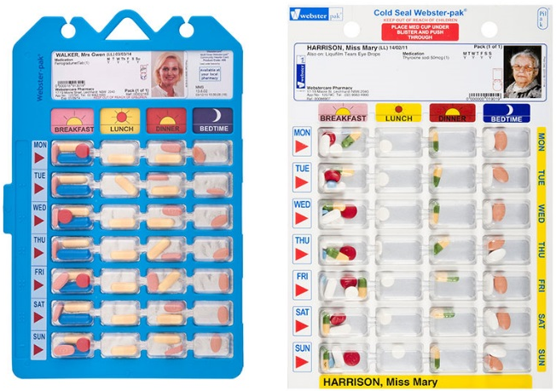
Dose Administration Aids (DAA)
Dose administration aids (DAA), such as those pictured on the right, are medication management systems designed to make taking medicines easier.
- DAA make taking medicine simpler by separating all the medicines you take into different times of the day, and/or separate days of the week.
- Some DAAs are in the form of a calendar box, and some are in the form of a dosette, or a sachet roll.
- DAA are usually packed by a pharmacist for a small fee, and are collected from your pharmacy, anywhere from weekly to monthly.
- If patients feel confident, dosettes can be purchased from pharmacies and the patient can pack their own dosette box.
- When using a DAA, any changes to medication needs to be passed on to the pharmacy as soon as possible, otherwise they will continue to pack the dosette without the new changes.
Different formulations: Modified Release (MR) / Slow Release (SR) / Extended Release (XR)
Oral medications are available in different formulations that change the way they are released.

- Patients may see and hear the terms (on medication packaging) slow-release or SR, modified-release or MR,
extended-release or XR.
- These terms all mean the same thing: the medication works over a longer period of time than the standard tablets.
- Sometimes this means a patient will need to take fewer
tablets per day.
- Slow-release formulations must be treated differently
to standard tablets – they must be swallowed whole and
cannot be crushed, but some can be dissolved in water.
- Speak to your pharmacist if you are having trouble
swallowing your medications.

Taking My Medication With or without food? Your pharmacist will tell you if the medicine should be taken on an empty stomach, with food, or if it does not matter.
- The reason medications are taken with food varies – sometimes it is to reduce the chance of stomach upset (such as nausea or vomiting) or to increase the amount of medicine absorbed.
- If a medication should be taken on an empty stomach, this usually means that the medication is absorbed better (and works better) when it is taken either 30 minutes before food, or 2 hours after food.
- If the label doesn’t say how to take the medication and the pharmacist hasn’t told you, it can be taken with or without food.
What does ‘when necessary’ mean? Some medicines don’t need to be taken regularly. These medications will say ‘when necessary’ or ‘when required’ on the label. Usually, these medicines are used to treat something that only happens occasionally.
- This means that the medication only needs to be taken when your symptoms start, or on the directions of the doctor.
- If you find that you need to take the ‘when necessary’ medication regularly, you should speak to your doctor about this, as it may mean the medicine or the dose is not right.

How long do they take to start working? Medications that work within the brain are called psychotropic medicines.
- These medications generally take days to weeks to work because they slowly cause changes in the brain.
- These medicines generally take up to a couple of weeks for the patient to feel a change, and can take up to 8 weeks to reach their full effect.
- Because of these gradual changes, these types of medications should not be stopped suddenly. If a psychotropic medication needs to be stopped or changed, the doctor will usually do this slowly over time, to reduce any symptoms or side effects that may occur if they are stopped suddenly.
How can your pharmacist help?
When it comes to medication, pharmacists are the experts. If you have any questions or concerns about your medication, a pharmacist can give you information or help find a solution, and are happy to work with your doctor. They can also help you manage your medications, organise a dose administration aid, manage side-effects, and make sure you are taking the best possible medication for you.
Accessing further information:
Resource | Purpose | Address
NPS MedicineWise | Comprehensive resource surrounding medication use | https://www.nps.org.au/consumers
MedicineWise App | Phone app for medication management | https://www.nps.org.au/consumers/medicinewise-app
MedSearch App | Phone app to look up information about medications | www.tga.gov.au/medsearch-app
Find a Pharmacy that packs DAA | Search engine for pharmacies that pack DAAs | https://www.findapharmacy.com.au/our-services/dose-administration-aids
BetterHealth Channel | Government website that summarises health conditions | https://www.betterhealth.vic.gov.au/

