Basic At Home Exercises:
Adapted from Queensland Government, Healthier. Health. (2020).
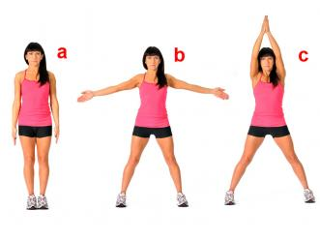
Jumping Jacks: Start by standing with feet together, knees slightly bent and arms to yourside. Jump while raising arms and separate your legs to the sides. Land on your feet with legs apart and arms above your head.

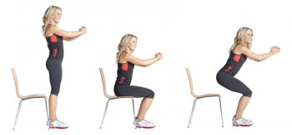
Chair Leg Squats:Stand in front of chair and keep your knees aligned, slowly squat into sitdown onto chair and then stand back-up. Your kneesshould not pass over your toes.

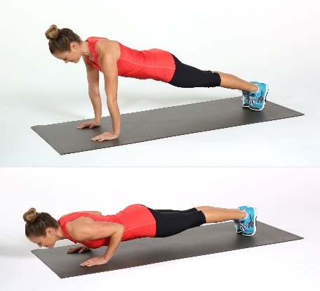

Push ups: Put your hands shoulder width apart on the floor, bend your knees and cross your legs. Bend your elbows and lower yourself down keeping your back straight. Squeeze your tummy. Push back away from the floor and straight elbows.
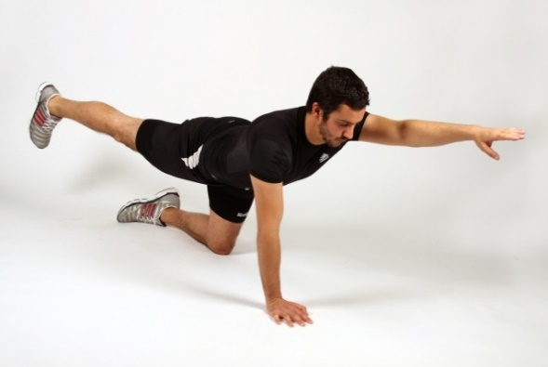
Superman: Start on your hands and knees with your back straight and squeeze your tummy. Keeps your hips low. Raise your right arm and left leg at the same time and straighten your elbow and knee. Pause and then lower to the starting position. Switch to the other side.

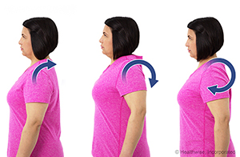
Shoulder Rolls: Rotate your shoulders clockwise and then anti-clockwise. Repeat.

